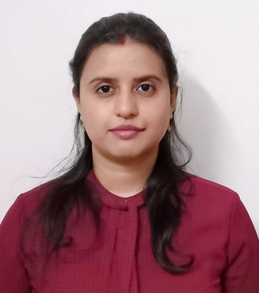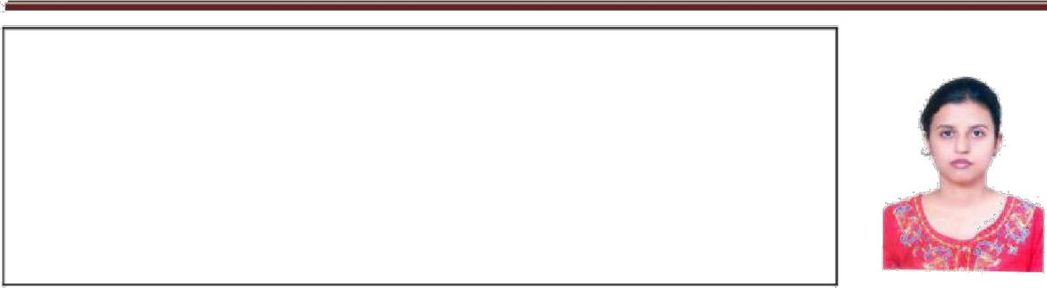

Archita Bhattacharya

With 4 years and 6 months of experience in full life cycle of analysis, development, testing and support of applications. Seeking to work in challenging career where I can demonstrate my ability and contribute to meet the goals and objectives of the Organization & to prove myself as a worthy asset to the Organization.

### architabhattacharya104@gmail.com +91-8961766383

 Hinjewadi, Pune-411057

<https://www.linkedin.com/in/archita-bhattacharya-a76002b8/>

**SKILLS**

1. **Programming Languages:**

**C#**

1. **Microsoft Technologies:**

**ASP .NET, MVC,WPF.**

1. **Database:   
   SQL Server,Sqlite**
2. **Coding Tools:   
   Visual Studio.**
3. **BI Tool:   
   Tableau**
4. **Test Management Tools: PROTON.**
5. **Ticketing Tools:   
   Service Now**

**APPLICATIONS:**

**Microsoft Office Utilities,**

**Comfortable working in  
 windows based operating   
 systems**

# CERTIFICATIONS

* **Udemy:**

**Tableau**

**LANGUAGES**

### English

* Hindi
* Bengali

**WORK EXPERIENCE**

**Cognizant Technology Solutions (April 2018- Present)**

* 3+ years of experience in health care domain.
* Proposed and Developed automation themes for Health Care client for the purpose of maintaining user data for various applications and a workflow monitoring dashboard using ASP Dot Net, SQL.
* Understanding client’s requirements and working closely with clients and other stakeholders.
* Involved in various Service Improvements for clients in handling process flows, maintaining data integrity, application lifecycle management and for continuous throughput across the towers in the project.
* After sanity check prepared test cases for all environment either pen paper based or using PROTON tool depends on application type (Gxp/NonGxp).
* Recognized as one of the Top Automation Contributor across the tower.

**DreamzTech Solutions Pvt. Ltd. (August 2017-March 2018)**

* Responsible for Development and implementation of Point of Sale (POS) system in WPF.
* Worked on backend code(C#), design (WPF controls) and creation of database (SQL Server & Sqlite).
* After task completion checked the updated functional part in POS system and prepared cases in excel file.

**Exactlly Digital Solutions Pvt. Ltd. (August 2016-July2017)**

* Responsible for Development and implementation of Human Resources Management System (HRMS) Tool.
* Worked on backend code(C#) in MVC model, design (DevExpress controls) and creation of database (SQL Server).
* After task completion checked every updated functional part in HRMS tool and prepared cases in excel file.

**EDUCATION**

**B.Tech(**2015**), Computer Science & Engineering**

*Bengal Institute of Technology*